Press release

Experts in refrigeration to unveil largest product lineup to date at KBIS 2022

⸺
Liebherr’s new addition to their Monolith collection along with newly announced concept unit set to be on display
Liebherr Refrigerators and Freezers to showcase new fully-integrated refrigerators line, debut in-person the Monolith Bottom Freezers, and invite attendees to experience the global reveal of an innovative refrigeration concept.
Miami, FL (USA), January 1, 2022 – Liebherr Refrigerators and Freezers, a global leader in the refrigeration industry for over 60 years, will introduce its broadest product lineup ever to the US market at the 2022 Kitchen & Bath Industry Show, taking place in Orlando, FL from February 8-10, 2022. The unprecedented variety of products — ranging in design, aesthetics, and features — are all built with the performance and engineering for which the brand is known. Among the featured product areas to debut are: the new fully integrated refrigeration lines offering refreshed versions of the company's original European-styled units; the 30-inch, 36-inch, and French Door Monolith Bottom Freezers; and a state-of-the-art concept model of a style-forward, compelling and innovative refrigerator.
"At Liebherr, 2022 is going to be a creative and exciting year," says Alex Squarize, Divisional Director of Liebherr Refrigerators and Freezers. "We're looking forward to sharing our much-anticipated products with the consumers, designers and architects whom we trust the most. It's going to be an extraordinary event."
Getting its KBIS in-person debut are the Bottom Freezers from the Monolith line. Designed for consumers who want the best in innovation and design, the Monolith Bottom Freezers are designed to enhance luxury and performance in kitchens across North America, without compromising valuable space.
Features of the Bottom Freezers include the Monolith's intuitive electronic touch-control panel, the InfinitySwipe; Liebherr's high-performance PowerCooling system; BioFresh-Plus technology and a SmartDeviceBox which can be controlled via a smartphone or tablet, activating settings and features while on-the-go.
Liebherr will also debut the newly branded Pure and Prime lines. These fully integrated refrigerators are US versions of the brand's popular European models which are smaller, and more economical than the original Monolith. They each come standard with: DuoCooling, which uses two separate refrigeration circuits to ensure no air is exchanged between the fridge and freezer compartments; EasyFresh or BioFresh technologies, with customized low and high humidity settings to keep food fresh for longer, and Liebherr's high-performance PowerCooling system, which maintains an even temperature throughout the interior.
Like different trims on a luxury car, the Pure line offers all the Liebherr quality in a standard model. The Prime offers upgraded features such as stainless steel, special lighting concepts, InfinitySpring and adjustable interior features.
New concepts unveiled
The main event of this year's showcase will be the unveiling of Liebherr's concept unit. Attendees can expect to interact with an optimum version of the European model, on stage with open shelves. The glass and metal structure is touted as an aesthetic achievement, in addition to an engineering one. Attendees and designers will have the opportunity to ask questions, provide feedback and contribute to the look and function of the final product.
"In addition to all the great products, what makes KBIS an event we look forward to is connecting with old friends and colleagues again," says Jonathan Barfell, Senior Marketing Manager, Refrigerators and Freezers. "We can't wait to catch up and share the many new things we've had a chance to work on over the last couple of years".
Liebherr's reputation as a world leader in technology and design stems from listening to what matters most to customers, then meeting their needs with the most advanced technology, in the most attractive forms. Liebherr products are created to integrate seamlessly into all styles of American kitchens, with vast customization potential, advanced technology and an elegant look with cutting-edge features.
The Monolith Bottom Freezer will be available in showrooms across the in the next few weeks. The refrigerators come in 30- and 36-inch size options as well as a French Door configuration. The new Pure and Prime units will be available summer 2022.
For more information on Liebherr and their new products, please visit home.liebherr.com or you can stop by Booth W1151 at KBIS 2022.
About Liebherr USA, Co.
Liebherr USA, Co. based in Newport News, VA provides sales and service on behalf of ten different Liebherr product segments: earthmoving, material handling, mining, mobile and crawler cranes, tower cranes, concrete technology, deep foundation machines, maritime cranes; components, and refrigeration and freezing.

About the Liebherr Group
The Liebherr Group is a family-run technology company with a highly diversified product portfolio. The company is one of the largest construction equipment manufacturers in the world. It also provides high-quality and user-oriented products and services in a wide range of other areas. The Liebherr Group includes over 140 companies across all continents. In 2021, it employed more than 49,000 staff and achieved combined revenues of over 11.6 billion euros. Liebherr was founded in Kirchdorf an der Iller in Southern Germany in 1949. Since then, the employees have been pursuing the goal of achieving continuous technological innovation, and bringing industry-leading solutions to its customers.

Images
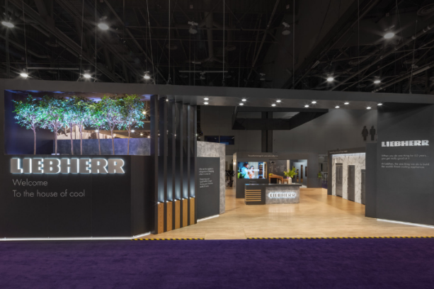
Storyliebherr-KBIS 2022.png
Liebherr booth featuring Monolith Bottom Freezers at KBIS 2022

Contact
Ana Cabiedes
General Manager, Marketing, Liebherr USA, Co.
Phone: +1 757-240-4250
E-Mail: ana.cabiedes@liebherr.com
Jonathan Barfell
Senior Marketing Manager, Liebherr USA, Co., Refrigerators and Freezers
Phone: +1 305-817-7500
E-Mail: jonathan.barfell@liebherr.com
Published by
Liebherr USA, Co.
Newport News / USA
www.liebherr.com

