Press release

Liebherr implements new field tech team to enhance support for service technicians, installers, dealers & distributors

⸺
The initiative supports Liebherr USA, Co. Refrigerators and Freezer’s teams as they deliver exceptional customer care

Miami, FL (USA), July 12, 2021 – To meet the goal of improving relationships in the field and increasing customer satisfaction, Robert Marriott, Head of Customer service for North America, has initiated a program designed to provide education and technical training for Liebherr USA’s Refrigerators and Freezer’s partners. This initiative is designed to make selling and installing products seamlessly, boosting confidence in those who serve as important frontline to our consumers.
To provide greater distributor and dealer support, Liebherr Refrigerators and Freezers has brought onboard three experienced and talented field technical representatives who will nurture relationships and ensure our partners understand Liebherr products inside and out. Michael Pullano will be the point of contact in the eastern Region, Tiffany Philips will be focusing on the central states, and Jeff Walter will deliver in-person, onsite training in the West.
“Relationships are at the core of who we are,” said Marriott. “We feel we can work even closer with our partners to better achieve our ultimate goal: consistently providing the excellent service experience customers and partners expect from the Liebherr brand. “
The team will recruit and maintain the authorized service providers (installers and after-sales) in their assigned territories. Liebherr’s authorized service providers will be supported through site visits, reviews of the brand’s performance goals, and managing parts stock.
The plan provides residential and commercial technical product training to all of Liebherr’s partners, in addition to providing in-home service if needed. Through this program, the team will be engaging directly with dealers, distributors, service agents, and installers to provide the most comprehensive training and product information.
According to Marriott, the objective is “to have a true Liebherr presence and representation in the field that will increase customer satisfaction and reduce customer escalations. We feel the best way to achieve this is by showing dealers and distributors that they have our full support. It is an objective that fully aligns with Liebherr’s commitment to quality and values.”
About Liebherr USA, Co.
Liebherr USA, Co. based in Newport News, VA provides sales and service on behalf of ten different Liebherr product segments: earthmoving, material handling, mining, mobile and crawler cranes, tower cranes, concrete technology, deep foundation machines, maritime cranes; components, and refrigeration and freezing.
About the Liebherr Group
The Liebherr Group is a family-run technology company with a highly diversified product portfolio. The company is one of the largest construction equipment manufacturers in the world. It also provides high-quality and user-oriented products and services in a wide range of other areas. The Liebherr Group includes over 140 companies across all continents. In 2021, it employed more than 49,000 staff and achieved combined revenues of over 11.6 billion euros. Liebherr was founded in Kirchdorf an der Iller in Southern Germany in 1949. Since then, the employees have been pursuing the goal of achieving continuous technological innovation, and bringing industry-leading solutions to its customers.

Images
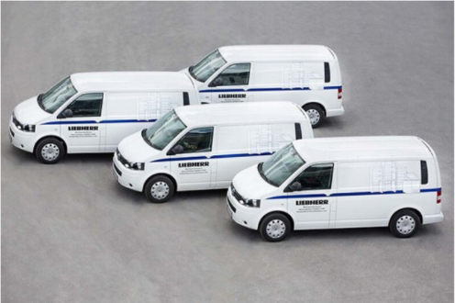
Story Liebherr-Liebherr Service Vans.png
Fleet of Liebherr service vans

Contact
Ana Cabiedes
General Manager, Marketing, Liebherr USA, Co.
Phone: +1 757-240-4250
E-Mail: ana.cabiedes@liebherr.com
Jonathan Barfell
Senior Marketing Manager, Liebherr USA, Co., Refrigerators and Freezers
Phone: +1 305-817-7500
E-Mail: jonathan.barfell@liebherr.com
Published by
Liebherr USA, Co.
Newport News / USA
www.liebherr.com

